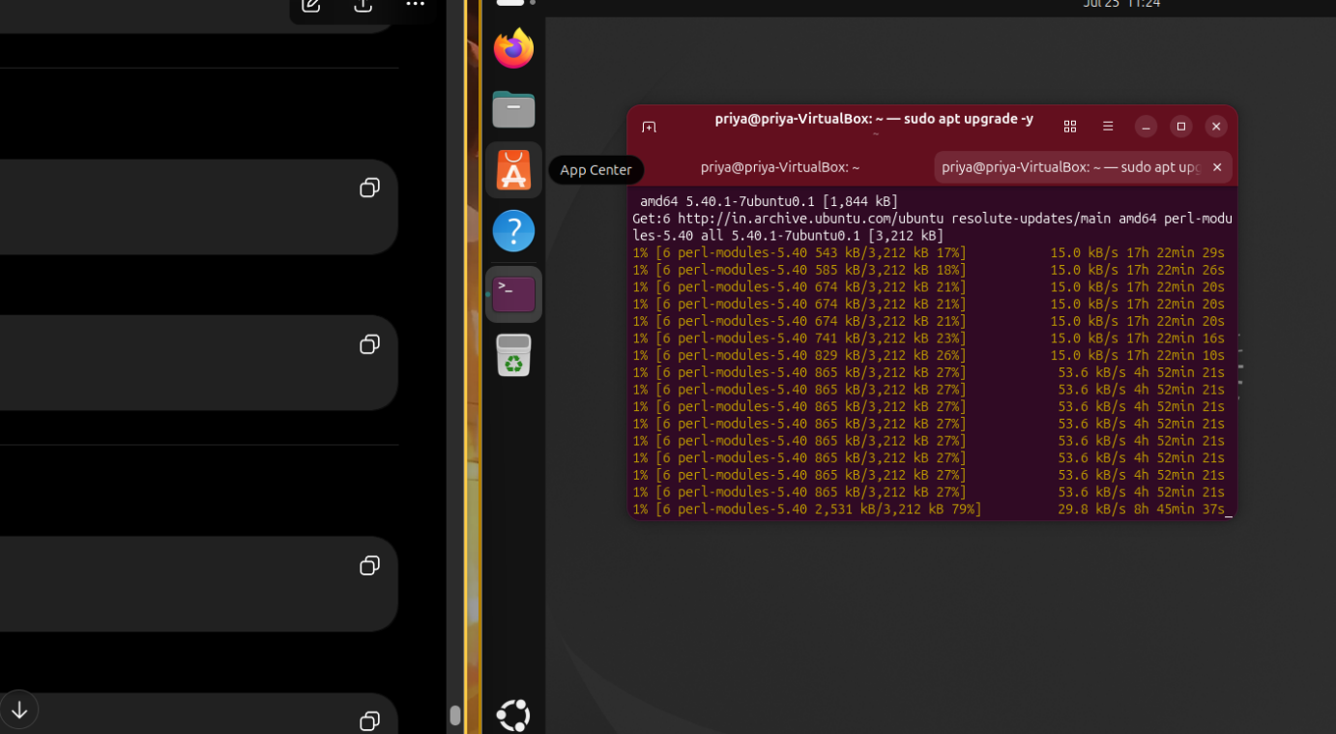

Yes, you can stop it if your only goal right now is to start developing ACTDRS.
Why were we running sudo apt upgrade -y?
The purpose is to:
- Update installed software to the latest versions.
- Apply security patches.
- Fix bugs.
- Improve system stability.
It is recommended, but not mandatory before you start coding.

For ACTDRS, what do we actually need?
We only need:
- ✅ Python
- ✅ pip
- ✅ Git
- ✅ VS Code
- ✅ Internet (to install Python libraries)
We do not need every Ubuntu package to be upgraded before writing our first program.

What should you do now?
Since the download is extremely slow:
- Press Ctrl + C in the Ubuntu terminal.
- It will safely stop the upgrade.
- Then check these commands one by one:
python3 --version
pip3 --version
git --version
If any of these are missing, we'll install only that package instead of upgrading the whole operating system.

Our priority
Our goal is not to have the newest Ubuntu.
Our goal is to build:
AI-Powered Cyber Threat Detection and Response System (ACTDRS)
So we'll spend time on coding and learning, not waiting hours for updates.

From now on
We'll follow this order:
- ✅ Verify Python
- ✅ Install pip (if needed)
- ✅ Install Git (if needed)
- ✅ Install VS Code (if needed)
- ✅ Create the ACTDRS project folder
- ✅ Write the first monitoring module (CPU, RAM, Disk)
This gets you building the project much sooner.

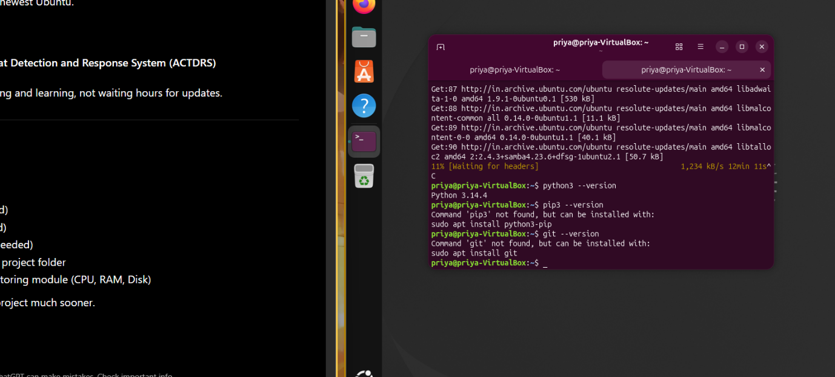

es, I looked at your screenshot. This is actually good news. Here's what it tells us:
✅ 1. Python is already installed
You ran:
python3 --version
Output:
Python 3.14.4
So you do NOT need to install Python. ✅

⚠️ 2. pip is NOT installed
You ran:
pip3 --version
Output:
Command 'pip3' not found
Ubuntu is telling you exactly how to install it:
sudo apt install python3-pip

⚠️ 3. Git is NOT installed
You ran:
git --version
Output:
Command 'git' not found
Ubuntu tells you to install it with:
sudo apt install git

Before installing pip and Git
I noticed something important in your screenshot.
The upgrade process is still running in another terminal:
11% [Waiting for headers]
This means apt may still be busy.
First, stop the upgrade
Go to the terminal where sudo apt upgrade -y is running.
Press:
Ctrl + C
It should stop and return you to a prompt like:
priya@priya-VirtualBox:~$

Then install only what we need
Run these commands one at a time:
sudo apt update
Then:
sudo apt install python3-pip
After that:
pip3 --version
Then install Git:
sudo apt install git
Check:
git --version

If you get an error like:
Could not get lock /var/lib/dpkg/lock-frontend
or
Waiting for cache lock
that means the previous upgrade is still running. In that case, stop it first with Ctrl + C before trying to install anything else.

Current status
Component | Status
Ubuntu | ✅ Installed
Python | ✅ Installed (3.14.4)
pip | ❌ Not installed
Git | ❌ Not installed
ACTDRS | ⏳ Not started yet
You're making good progress. Once pip and git are installed, we can create the ACTDRS project and begin writing the first monitoring module.

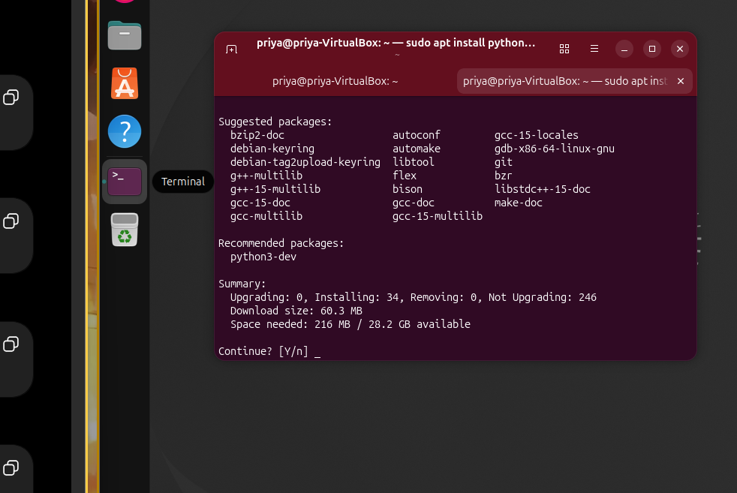

Yes, this is exactly what we want to see. 👍
The installation is waiting for your confirmation.
Your terminal says:
Continue? [Y/n]
This means Ubuntu is asking:
"Do you want me to install python3-pip?"
What you should do
Simply type:
y
and press Enter.
Ubuntu will then start downloading and installing python3-pip.

What this screen tells us
- ✅ Python is already installed.
- ✅ python3-pip is ready to be installed.
- ✅ It needs about 216 MB of disk space.
- ⚠️ It also says 246 packages are not upgraded.
That last message is not an error. It only means your Ubuntu system has many available updates. You can ignore those for now because our goal is to install pip, not upgrade the entire operating system.

After the installation finishes
Run:
pip3 --version
You should see something like:
pip 25.x.x from /usr/lib/python3/dist-packages/pip (python 3.14)
If you see that, pip is installed successfully.

Next step
After that, install Git:
sudo apt install git
Then verify it:
git --version
Once both pip and git are working, we'll create the ACTDRS project structure and write your first cybersecurity monitoring program.
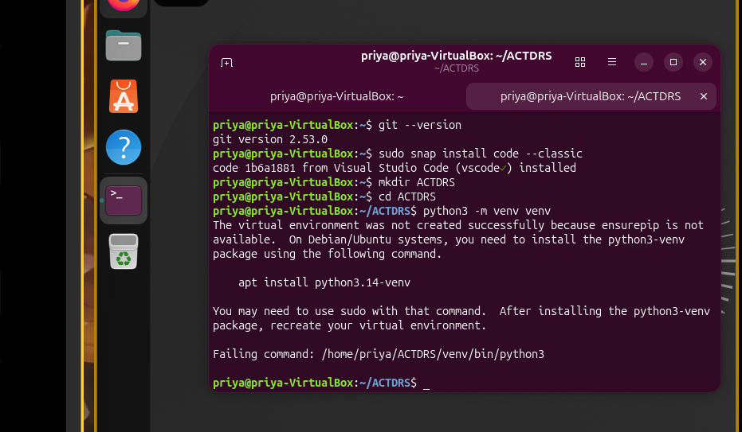

Yes, I checked your screenshot carefully. Everything up to Step 8 is correct. 👍
You have successfully completed:
- ✅ Python installed
- ✅ pip installed
- ✅ Git installed
- ✅ VS Code installed
- ✅ Created the ACTDRS folder
The error is only at Step 9, and Ubuntu is clearly telling you what is missing.

Why did this error occur?
You ran:
python3 -m venv venv
Ubuntu replied:
The virtual environment was not created successfully because ensurepip is not available.
This means
The venv package is not installed.
It is not a Python error and not your mistake.

Step 1: Install the venv package
Since your Python version is 3.14, Ubuntu recommends:
sudo apt install python3.14-venv
Type exactly that command and press Enter.
When it asks:
Continue? [Y/n]
Type:
y
and press Enter.

Step 2: Verify it installed
After the installation finishes, stay inside your ACTDRS folder:
cd ~/ACTDRS
Now run:
python3 -m venv venv
This time, it should complete without any error.

Step 3: Activate the virtual environment
Run:
source venv/bin/activate
If successful, your terminal prompt will change from:
priya@priya-VirtualBox:~/ACTDRS$
to something like:
(venv) priya@priya-VirtualBox:~/ACTDRS$
That (venv) at the beginning means your virtual environment is active.

Why are we creating a virtual environment?
A virtual environment keeps your project's Python libraries separate from the rest of the system.
Without it:
Ubuntu Python
├── Library A
├── Library B
├── Library C
With a virtual environment:
Ubuntu Python
│
▼
ACTDRS
└── venv
├── Flask
├── psutil
├── pandas
├── scikit-learn
This means:
- Installing a library for ACTDRS won't affect other Python projects.
- Different projects can use different library versions without conflicts.
- If something breaks, you can delete the venv folder and recreate it.

One more thing
I noticed you're using Python 3.14.4, which is very new. Some Python libraries may not yet fully support it.
If we run into compatibility issues later, I may recommend using Python 3.12 LTS for this project because it's currently better supported by the cybersecurity and AI ecosystem.
For now, though, continue with 3.14 unless we encounter a specific problem.
Next step
Run:
sudo apt install python3.14-venv
Then:
python3 -m venv venv
If either command shows an error, send me a screenshot or copy the output, and I'll help you resolve it.
I checked your screenshot carefully. The error is exactly what I expected.
Error:
The virtual environment was not created successfully because ensurepip is not available.
Ubuntu even tells you the solution:
apt install python3.14-venv
So nothing is wrong with your project. You're just missing one package.

Step 9 (Fix)
1. Install venv
Run:
sudo apt install python3.14-venv
If Ubuntu asks:
Continue? [Y/n]
Type
y
and press Enter.

2. After installation finishes
Run again:
python3 -m venv venv
If successful, you won't see any message. It will simply return to the terminal prompt.

3. Check whether it was created
Run:
ls
You should see:
venv
along with any other files or folders in ACTDRS.

4. Activate it
Run:
source venv/bin/activate
Your terminal should change from:
priya@priya-VirtualBox:~/ACTDRS$
to
(venv) priya@priya-VirtualBox:~/ACTDRS$
That means your virtual environment is active.

One thing I noticed
Your Ubuntu has:
- ✅ Python 3.14
- ✅ Git
- ✅ VS Code
- ✅ pip
- ⏳ Missing python3.14-venv
Everything else looks good.

If python3.14-venv cannot be found
Sometimes Ubuntu repositories don't have the package for a very new Python version yet.
If you get an error like:
Unable to locate package python3.14-venv
or
Package 'python3.14-venv' has no installation candidate
Don't try random fixes. Send me the exact error message, and I'll guide you to the correct solution.

Before you continue
Run only this command:
sudo apt install python3.14-venv
Then tell me one of these:
- ✅ "Installed successfully"
- ❌ Copy the exact error message
Based on that, I'll give you the next step.

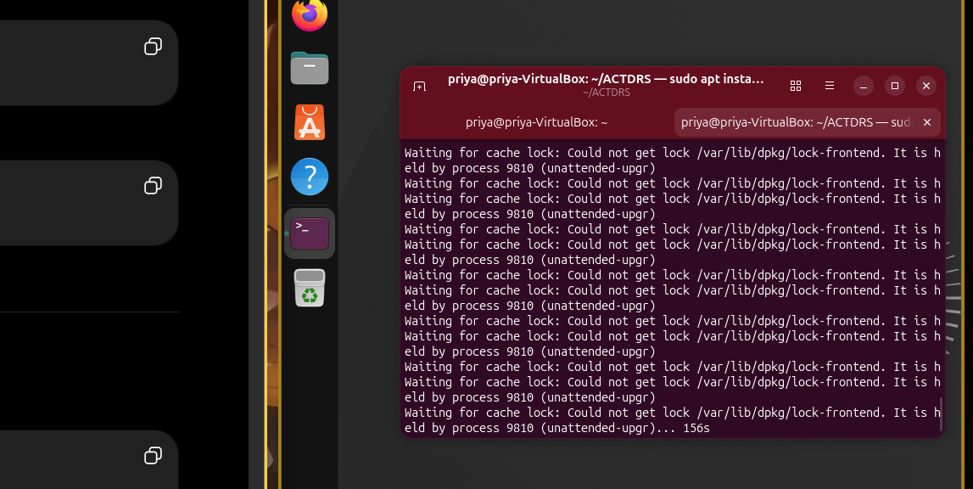
Install Flask inside Ubuntu, not in Windows Python.
Since your ACTDRS project is running on Ubuntu, all Python libraries should be installed in the Ubuntu environment.
Correct workflow
Windows
│
└── VirtualBox
│
└── Ubuntu
│
├── Python 3 ✅
├── Virtual Environment (venv) ✅
└── Flask ← Install here

If your virtual environment is already created
Go to your project folder:
cd ~/ACTDRS
Activate the virtual environment:
source venv/bin/activate
Your prompt should become:
(venv) priya@priya-VirtualBox:~/ACTDRS$
Then install Flask:
pip install flask
Verify it:
pip show flask

If your virtual environment is NOT created yet
Don't install Flask yet.
First complete:
- Install python3.14-venv
- Create the virtual environment
- Activate it
- Then install Flask
This keeps all ACTDRS dependencies isolated inside the project.

Summary
Software | Install where?
Python | ✅ Ubuntu
pip | ✅ Ubuntu
Git | ✅ Ubuntu
Flask | ✅ Ubuntu (inside the ACTDRS virtual environment)
VS Code | ✅ Ubuntu
Windows Python | ❌ Not used for ACTDRS
My recommendation is to finish creating the virtual environment before installing Flask. It will save you from dependency conflicts later in the project.

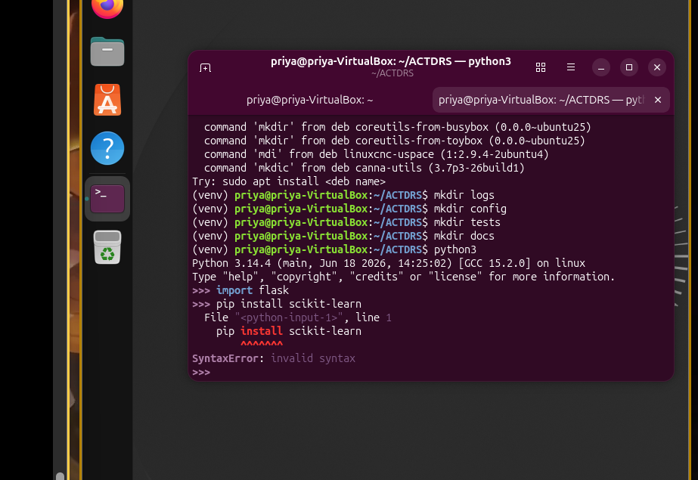

I looked at your screenshot. I can immediately see the problem.
The mistake
You are inside the Python interpreter.
Your prompt is:
>>>
That means Python is waiting for Python code, but you typed:
pip install scikit-learn
pip install ... is not Python code, so Python reports:
SyntaxError: invalid syntax

How to fix it
Step 1: Exit the Python interpreter
At the >>> prompt, type:
exit()
or press:
Ctrl + D
You should return to the Linux terminal and see something like:
(venv) priya@priya-VirtualBox:~/ACTDRS$
Notice:
- >>> = Python interpreter
- (venv) priya@...$ = Linux terminal (this is where you install packages)

Step 2: Install the AI library
Now run:
pip install scikit-learn
or, to be explicit:
python3 -m pip install scikit-learn
Do not type these commands after >>>.

Easy way to remember
Linux Terminal ✅
(venv) priya@priya-VirtualBox:~/ACTDRS$ pip install flask
(venv) priya@priya-VirtualBox:~/ACTDRS$ pip install scikit-learn
(venv) priya@priya-VirtualBox:~/ACTDRS$ python3 app.py
Python Interpreter ❌
>>> pip install flask ❌
>>> pip install scikit-learn ❌
>>> sudo apt update ❌
The Python interpreter is only for Python statements, for example:
>>> print("Hello")
>>> 5 + 10
>>> import flask

For ACTDRS
From now on:
- Ubuntu Terminal → Install software (apt, pip, git)
- Python Interpreter (>>>) → Write and test Python code only
- VS Code → Write your ACTDRS source code
You're very close. This is a common mistake when starting with Python on Linux, and now you know how to distinguish between the shell and the Python interpreter.

